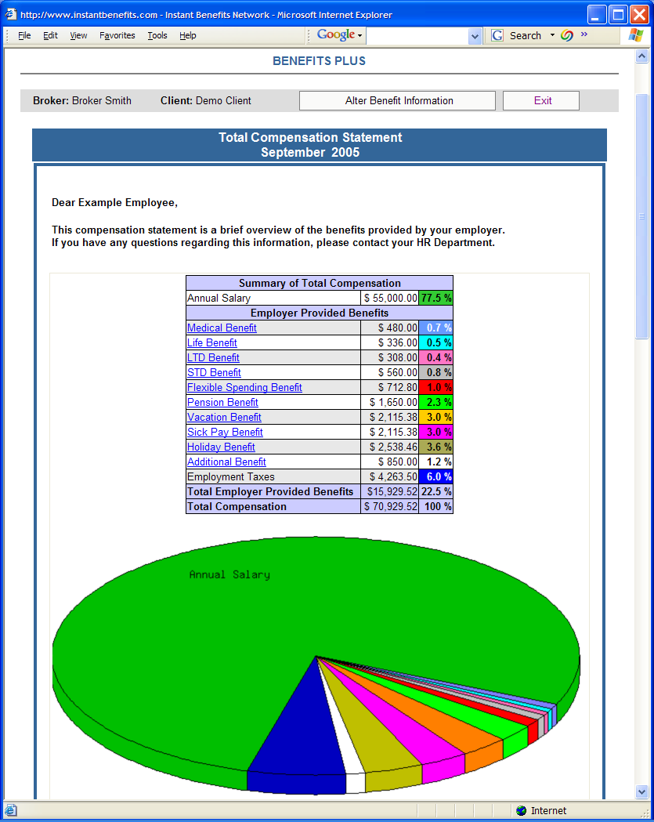
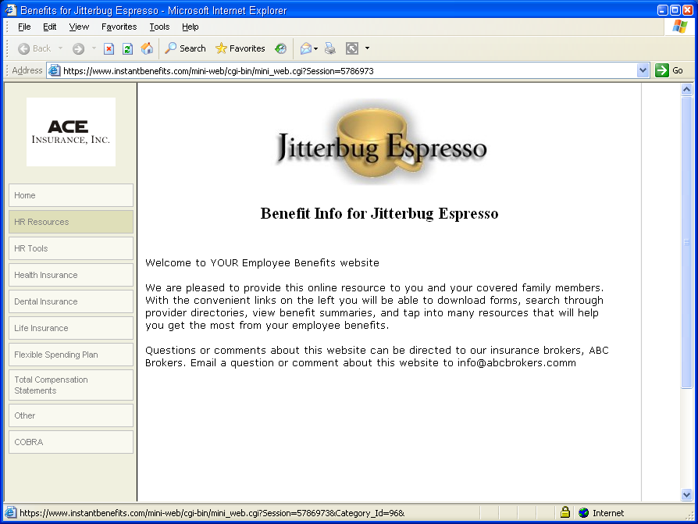






These statements help show the employee their total benefits and what their true value and cost to the employer actually are.

Change the way your employees think about their benefits and compensation package by providing them with an easy-to-use online tool that allows them to generate a personalized fringe benefit statement.

Place your Agency Logo or Contact Information here
Total Compensation Statements

Companies pay out a significant amount of money for fringe benefits while very few of their employees actually understand or appreciate this expense and commitment.

Benefits Plus!TM Total Compensation Statements can change the way employees think about their benefits and compensation packages.

This easy-to-use online tool allows the employees to produce their own benefit statements or they can be generated by the HR department for distribution or for one-on-one meetings such as performance reviews and employment interviews.

Unlike some other online statements, this service does not require the company to provide overly detailed and often hard-to-produce employee specific information. The wizard simply asks for only necessary data.

In addition, the system allows you to enter customized fringe benefit information that your company may offer that might not be standard employee benefits.

Your Agency or Individual Broker Contact Info Here

