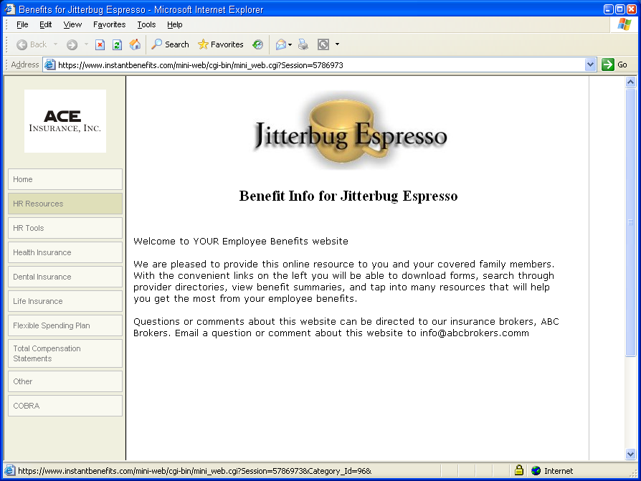





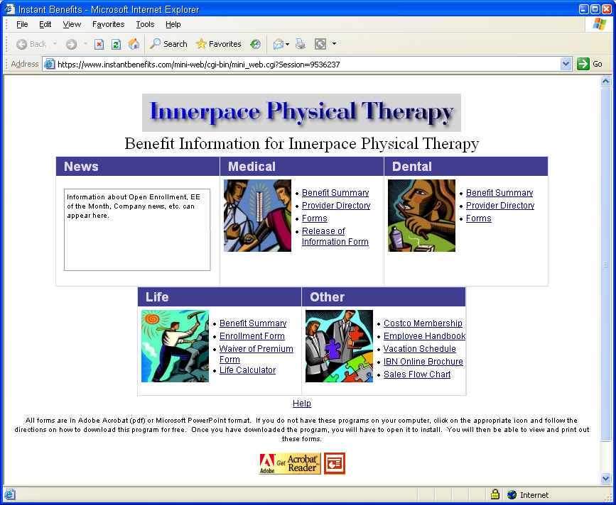

Our totally customizable benefit websites allow you and your company’s employees to access important and current benefit information and resources 24/7

Place your Agency Logo or Contact Information here
Custom Group Benefits Websites

Quickly and Easily Access Your Important Plan and Company Information Such as…

- Benefit Summaries
- Carrier Forms and Resources
- Online Provider Directories
- Plan Booklets
- Employee Handbooks
- New Hire Documents

As your broker, we can provide customized benefit websites to assist in bridging the gap in the employee communication process.

All of your plan information and any other documents and resources can be accessed through one easy to use web based portal, eliminating the need to navigate through a myriad of carrier sites and web pages to find the materials you and your employees need.

These sites eliminate the need to keep blank carrier enrollment and claim forms in your files as they are quickly downloaded and printed from your computer.

The benefit sites are well organized and provide quick access to resources and other online services that will allow your employees to handle many benefit administration tasks by themselves. This allows you more time to focus on more critical functions and aspects of your job.

We can also provide payroll stuffers, flyers, and other promotional pieces that will help educate your employees about the custom benefit website.

Your Agency or Individual Broker Contact Info Here

