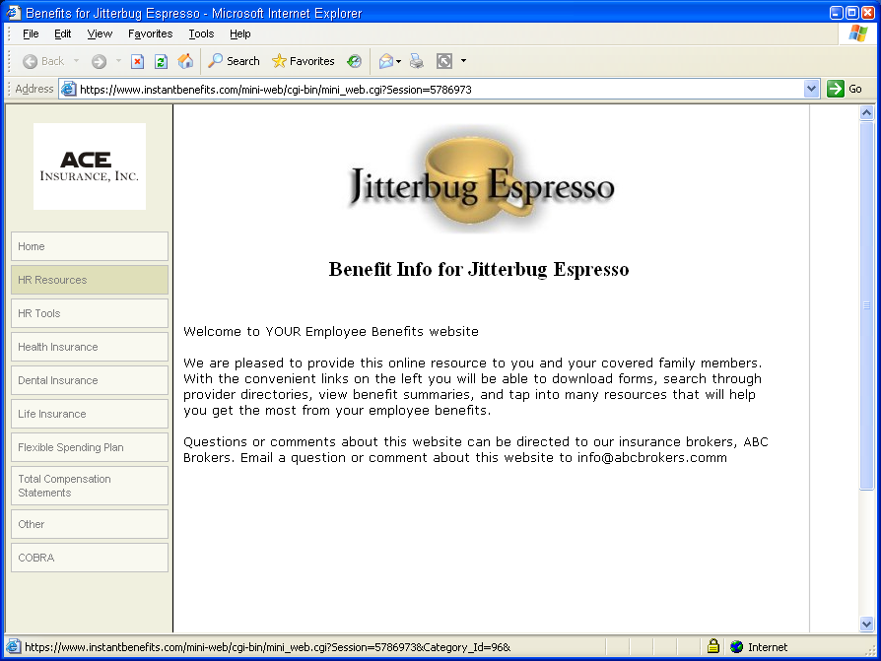






The HR Subscription Service provides owners and managers with the tools needed to set up your own internal HR systems along with the personal support of a professional HR coach.

Place your Agency Logo or Contact Information here
Your HR Department

Quickly and Easily Access, Edit and Print Relevant and Useful
HR Resources Documents Including…

Job Descriptions
Reference Checks
Personnel Action Forms
Confidentiality Statements
Travel & Expense Reports
Safety Surveys
Accident & Incident Reports
Employee Time Sheet
Time Off Request Form
Resignation Form
Termination Letter
Separation Checklist…

Many small and midsize companies find that coping with compliance issues can be a daunting task. Beyond just understanding the regulations, these companies need functional tools to assist them staying compliant.

With over 80 Forms, Samples and Federal and State Guidelines, your clients will have the tools they need to keep organized and compliant. Plus, unlimited calls to a professional HR coach can get you the answers you need to implementing policies, or solutions to employee relations problems, right over the phone.

All forms and templates are in Microsoft Word® and can be easily edited with your company name and letterhead or modified to meet your specific company protocols.

Included are forms pertaining to:
- Staffing and Hiring
- Policies, Procedures & Handbooks
- Health, Safety & Wellness
- Compensation & Benefits
- Managing Employee Performance
- Separation

Contact Info Here

