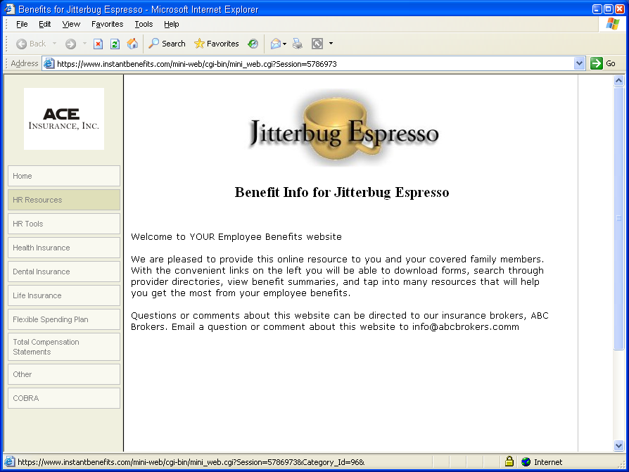





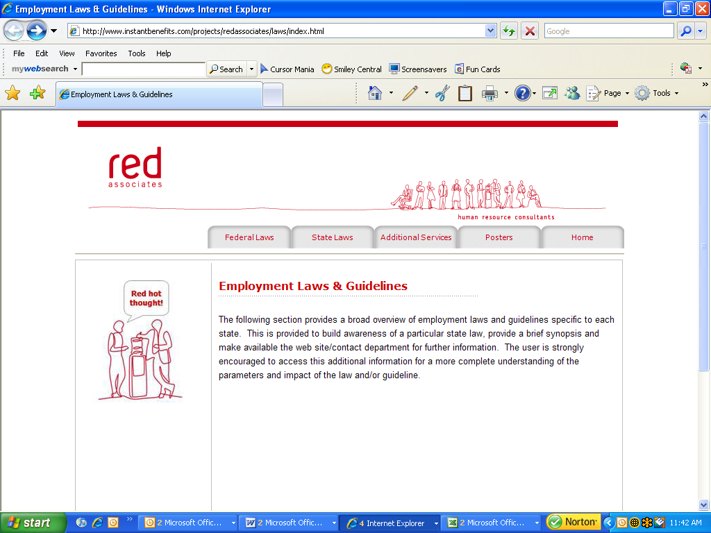

Critical Knowledge at your Fingertips!

Convenient Access to State and Federal Information

Place your Agency Logo or Contact Information here
Employment Laws & Guidelines

Quickly and Easily Access Important
HR Resources Including…

Employment Laws/Guidelines
- Federal Guides
- State Guides

Additional Services
- Federal and State
Websites
- Contact Information

- Posters and Forms

With frequent changes in state and federal laws, it can be difficult keeping up with employment issues in the workplace. Trying to grasp the complexities of these regulations can create headaches for even the seasoned HR professional.

Partnered with Red and Associates, this online resource offers a Federal and State Employment Law Overview, tailor-made for the business owner or manager who needs to understand how employment laws affect their business in easy to understand terms.

The state laws can be conveniently accessed on a state by state basis, providing the user with a quick, easy way to access up-to-date laws, guidelines and posters needed for any specific state along with all the federal employment laws.

Links to state and federal websites are included along with other contact information when more in-depth research is needed. Required posters and forms can also be easily downloaded in PDF format.

Contact Info Here

