


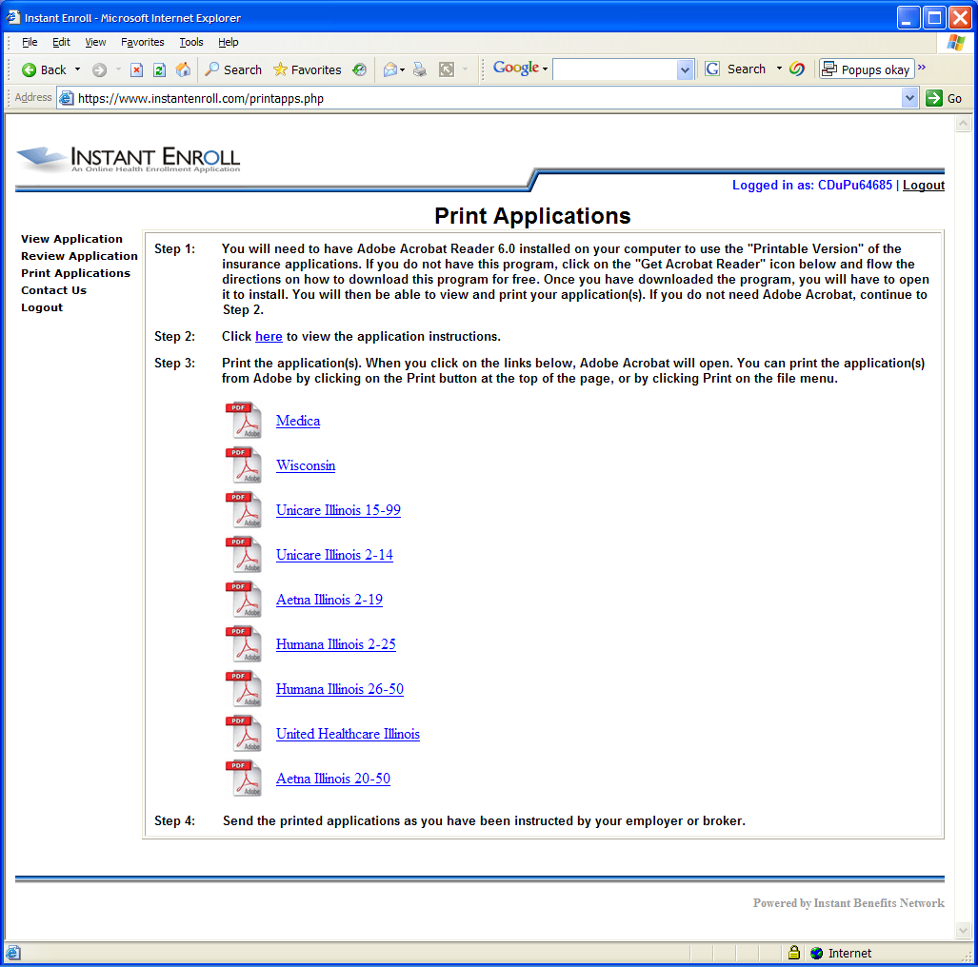
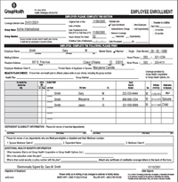



Advantages :

- The Census Upload feature greatly simplifies system setup.

- Brokers and Plan Administrators can access & print applications for employees

- Website system is 100% HIPAA compliant

- Each application document is complete and legible

Employers are often looking for a way to streamline the employee enrollment process for both large and small groups. Instant Enroll greatly reduces the time spent on carrier requests for missing information the enrollment process, while providing a way for employees to complete applications thoroughly online at work or at home.

Instant Enroll allows employees to choose the coverage they want for themselves and their family members via a secure website. Brokers or plan administrators can then print out a number of completed carrier health applications, or even electronically fax to the carriers’ premium billing department directly from the system.

Initial employee information can be easily entered into the system by simply uploading a census spread sheet. New hires and terminations can be entered and deleted as need keeping the census information up to date. The system can also be used specifically for new hires as a means to complete the chosen carriers’ enrollment forms.
Individual employee and dependent information can be saved in the system for future year’s renewals, further speeding up the process.

Because employees are required to complete all of the required information before continuing through the process, carriers receive their forms back with completely legible data. The result is an enrollment process that will go much smoother and your group will experience fewer service problems due to incorrect information entered by the carriers.

Your Agency or Individual Broker Contact Info Here

Make completing multiple carrier enrollment forms quicker and easier for your employees.

Place your Agency Logo or Contact Information here
Instant Enroll
Enrollment Form Populator

