

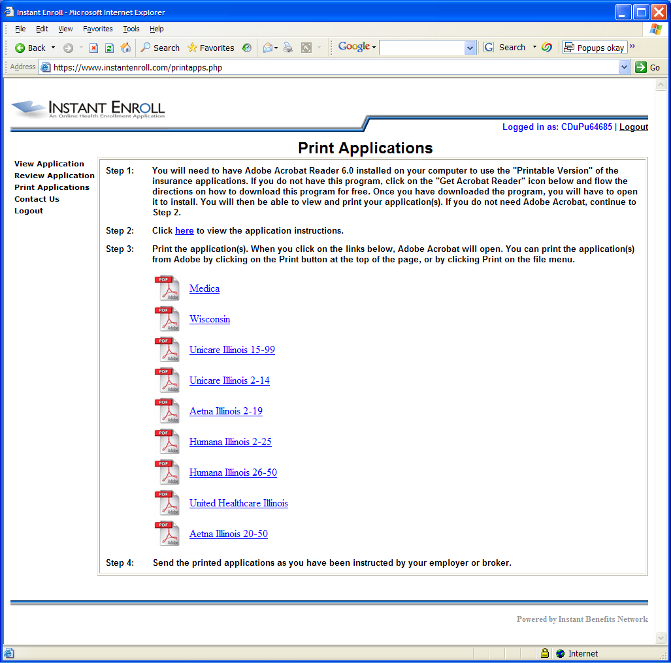
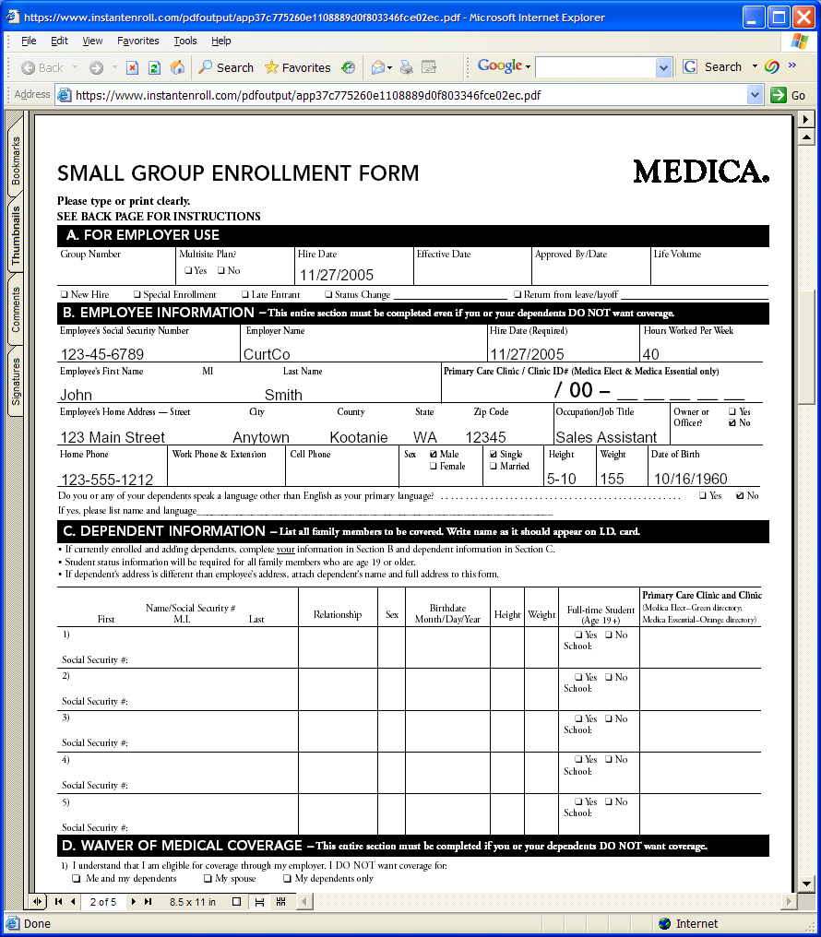




Advantages :

- Each employee fills out only one health questionnaire for themselves and their family members

- Brokers can access & print applications for employees

- Website system is 100% HIPAA compliant

- Each application document is complete and legible

Make completing multiple carrier enrollment forms quicker and easier for your employees.

Place your Agency Logo or Contact Information here
Instant Underwriter
Enrollment Form Populator

Small employer groups are often health underwritten which requires employees to complete long, detailed applications. Welcome to Instant Underwriter. This software greatly streamlines the underwriting process for small groups.

Instant Underwriter allows employees to fill out their and any dependant health information one time via a secure website and print out a number of completed carrier health applications. This online tool is an incredible time-saver for employees and makes marketing simpler for brokers.

Individual employee and dependant information can be saved in the system for future year’s renewals, again speeding up the process.

Initial employee information can be easily entered into the system by simply uploading a census spread sheet. New hires and terminations can be entered and deleted as need keeping the census information up to date. The system can also be used specifically for new hires as a means to complete the chosen carrier’s enrollment form.

Because employees are required to complete all of the required information before continuing through the process, carriers receive their forms back with no missing and completely legible data. The result is an enrollment process that will go much smoother and your group will experience fewer service problems due to incorrect information entered by the carriers.

Your Agency or Individual Broker Contact Info Here

