




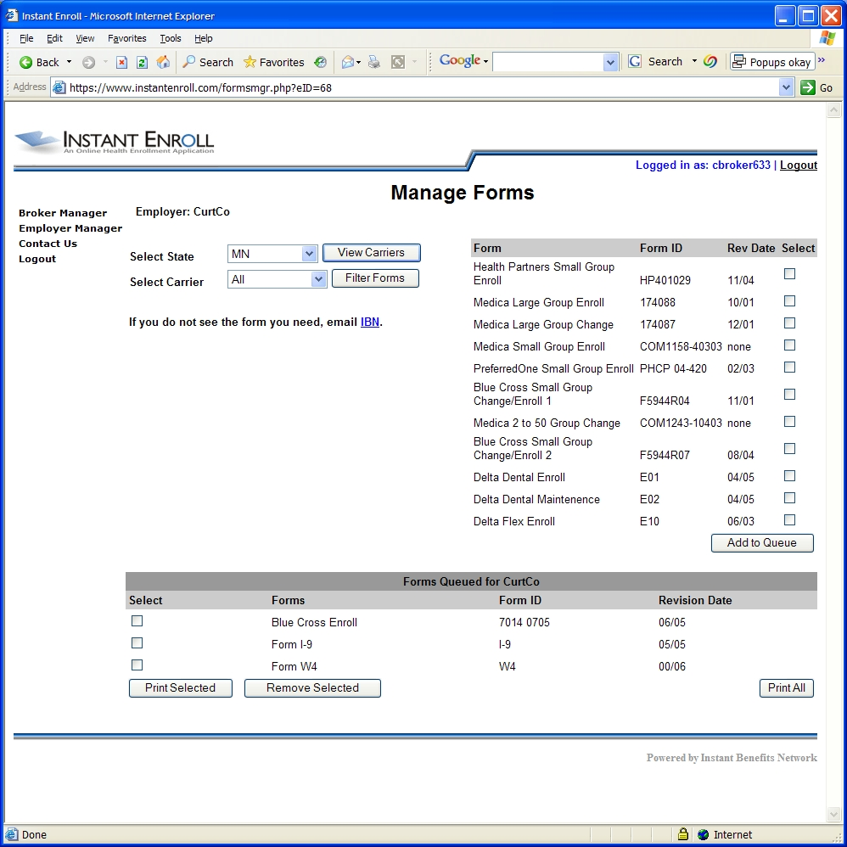
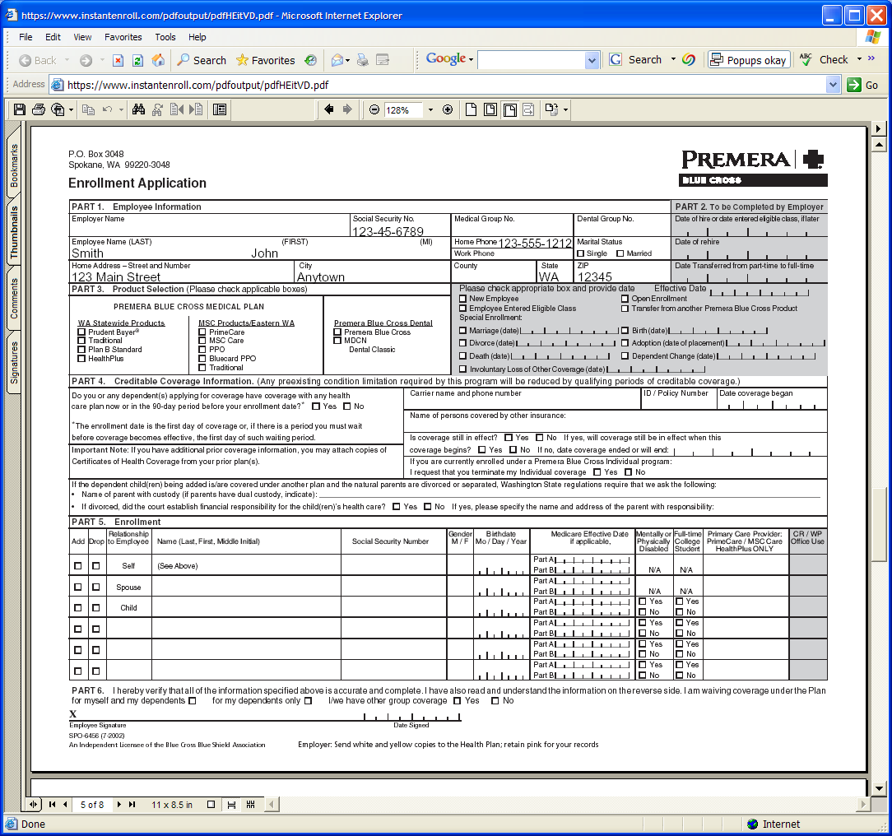

Pre-populate your plan’s carrier enrollment forms with employee specific information.

Place your Agency Logo or Contact Information here
Instant Apps
Enrollment Form Populator

Forms can include:

- Plan Enrollment Forms
  - Medical
  - Dental
  - Life
  - LTD
- W-4
- I-9
- Authorization for Automatic Payroll Deposit
- Emergency Contact Information

Changing carriers can be a confusing and difficult process for employees and employers. A significant amount of time can be wasted tracking down missing information or deciphering handwriting.
We are pleased to offer Instant Apps, a service that greatly simplifies this process. When changing carriers, our agency can provide carrier enrollment forms that are pre-populated with the employee contact information. All we need is an initial Excel file with the information. For future years, the information will be saved and updated as needed.
The result is an enrollment process that will go much smoother and your group will experience fewer service problems due to incorrect information entered by the carriers.
In addition, between renewals the plan administrator can use an online tool to enter, edit and remove employees and populate and print not only the carrier enrollment forms but also the standard federal forms and other employer specific forms. Signing up new hires has never been easier.

Your Agency or Individual Broker Contact Info Here

